The **Signal Analyzer** app is an interactive tool for visualizing, measuring, analyzing, and comparing signals in the time domain, in the frequency domain, and in the time-frequency domain. The app provides a way to work with many signals of varying durations at the same time and in the same view.

We write the code for import audio signal in matlab. We got the array form of sinnal in the workspace of the signal analyzer app.

We just drag and drop it on the main screen and got the time domain output.

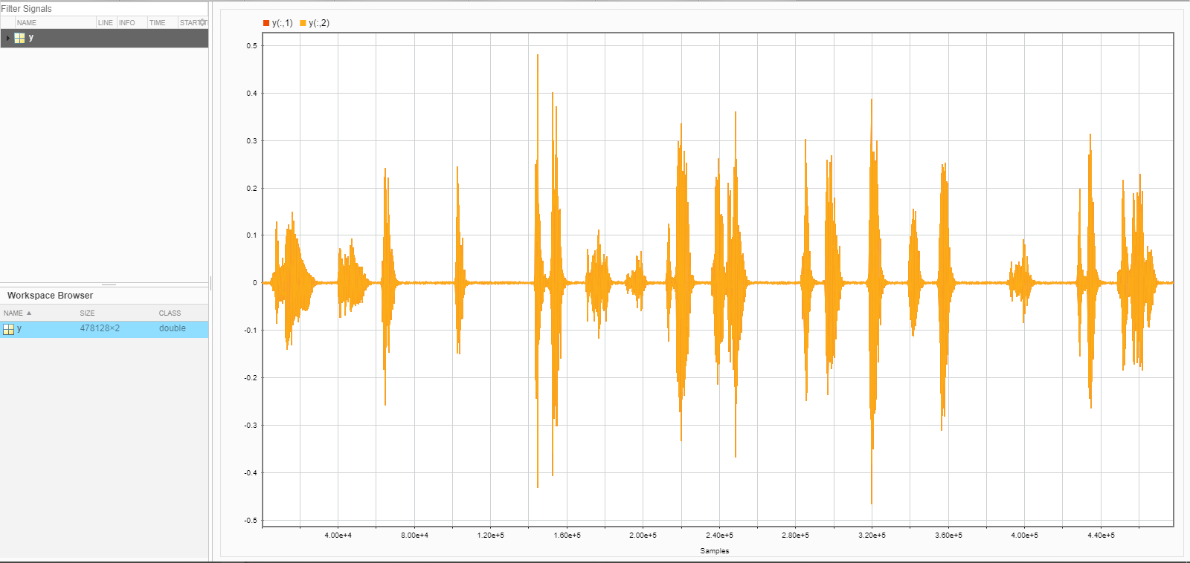

Now we will see the signal in frequency domainby clicking on spectrum.

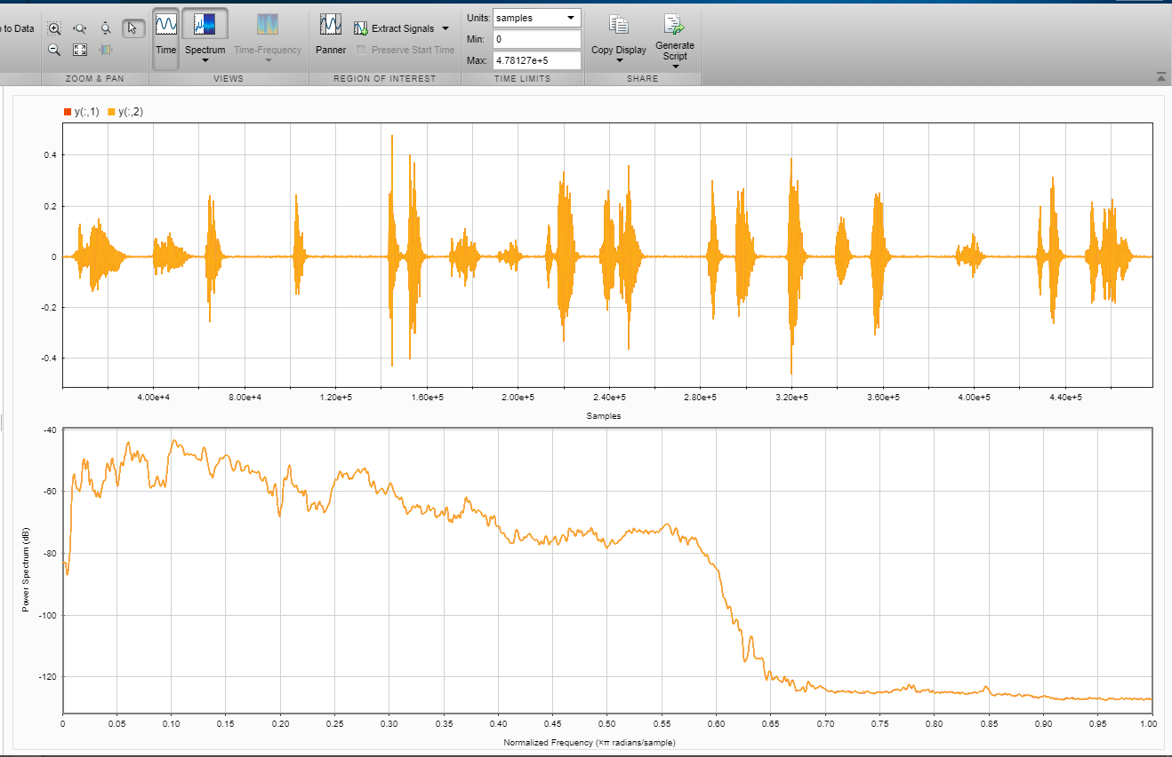

 select **Duplicate** to create a copy of the whale song. Remove the original signal from the display by clearing the check box next to its name in the Signal table. On the **Analyzer** tab, select **Highpass** from the **Preprocessing** gallery. On the **Highpass** tab, set the passband frequency to 925 Hz and the stopband attenuation to 80 dB. Use the default value for the steepness. Click the **Highpass** button to apply the filter**.**